- 1.
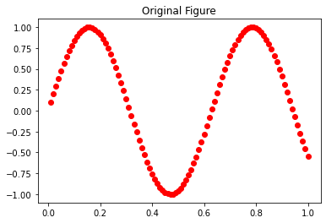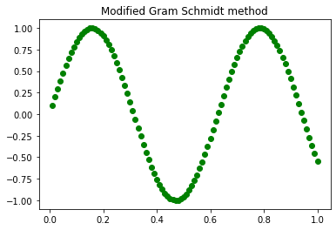
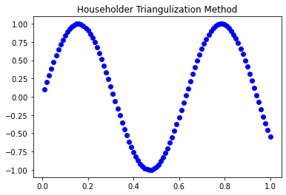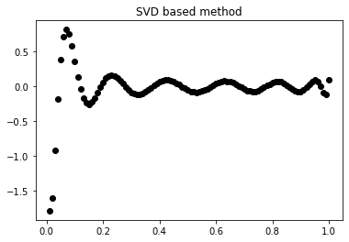
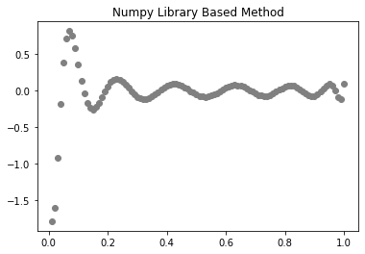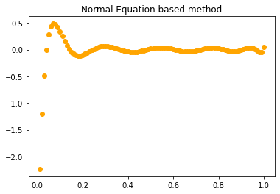

Here I used own code in Modified Gram-Schmidt method and Householder triangularization . For others, we used library functions as asked in the question. Discrepancy in those things might be related to small values in matrix A. (More on it in theory part)

4.
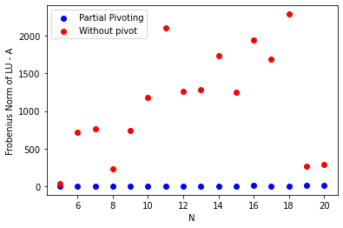
Clearly we observe the benefit of backward stability in LU Factorization with pivoting.

Code for 1 and 4 in the link.

